# **Length of Stay Prediction**

# Weekly Project Meeting Minutes

*The main purpose of the document is to capture all the work that has been done by the group over the course of one week and* ***not*** *to write down what was discussed in a single meeting. You should be meeting and/or working throughout the week*.

**Time group spent on project: 6 Hours**

**Group Number: 11**

**Group members present (Name, ID):**

* **Varinderjit Singh (0730482)**
* **Jaspreet Kaur (0730470)**
* **Kanchan Bagga** **(0732356)**

**Specific Activities from prior week:**

* **List brief description of activities carried out by group member**

We have done with the python coding and now working on report writing.

**Specific Output from prior week:**

* **Include brief summary of any written work, experiments, or code developed**
* **Attach actual output as a separate file when submitting minutes; for example, export your Jupyter notebook as an html file and upload that with your minutes**

This output shows the accuracy by neural networks.

Training set: 0.94

Test set: 0.89

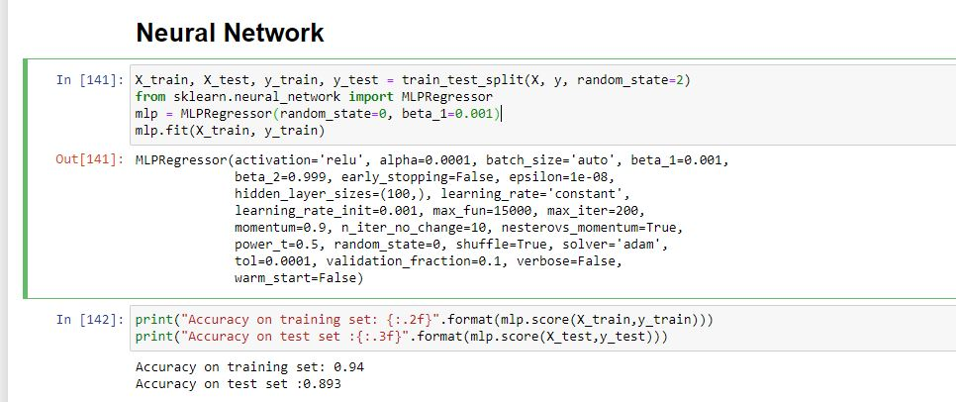

**On Target:**

* **Indicate the current status of your project**
  + _____ green: everything on track for completion by due date

**Challenges/Disagreements:**

* **List any particular challenges identified/discussed and possible solutions**
  + **include tasks causing a yellow or red flag for your project**

The main challenges we faced about the accuracy from all models because when we try the all models but always find the poor accuracy then we apply the neural networks, but that accuracy is also indicating the overfitting which is not the good for prediction.

* **List any notable disagreements and subsequent discussion and resolution**

Our group members are perform the work equally on this project so no issue about anything between us.

**Planned Activities for coming week:**

* **List brief description of activities by group member**
* **Make sure tasks are assigned to address yellow and red flag items**

We will be working on the python which we create some models, but accuracy is not correct so that’s why we apply the other models and methodology to do the correct work to the prediction accuracy.

We will be working on the report writing. Group Presentation will be prepared by all group members.